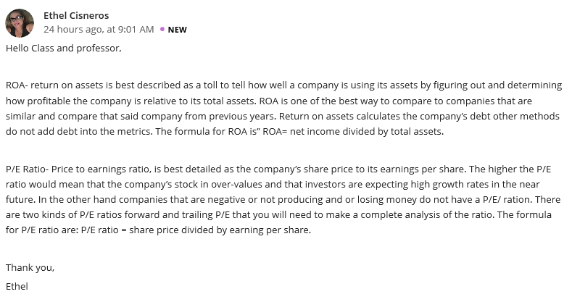

Hello Cisneros
I definitely concur with how you’ve described ROA. It measures how profitable a company is with respect to its assets or whatever resources it possesses. When you compare ROA of companies that are similar, it enables investors and analysts know how efficient a company uses its assets to generate income, which is an important point you forgot to mention. Since it tells how much profit an organization can make from its assets, investors can use this to find better stock opportunities. On the other hand, PE ratio is the connection between the stock price of a company and its earnings per share. You mentioned about the impact of a higher PE ratio. When you look at the PE of a stock, it doesn’t tell much about it unless it is compared to the PE of the previous periods or that of competitors from similar companies. Higher PE ratio means that investors will pay higher shares because it is highly likely that there will be growth in the future.

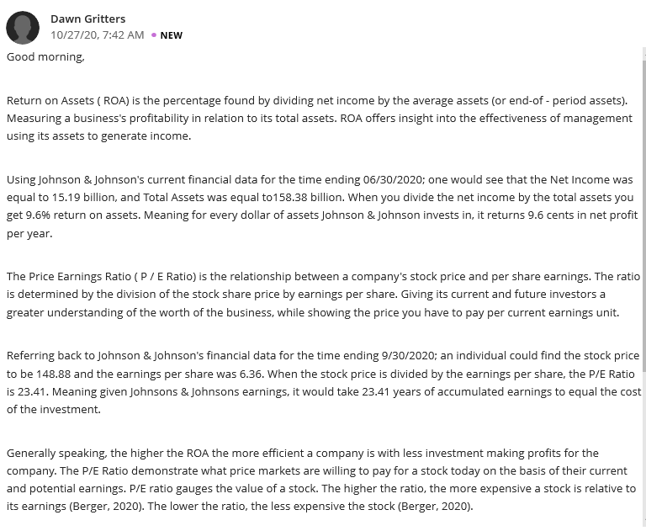
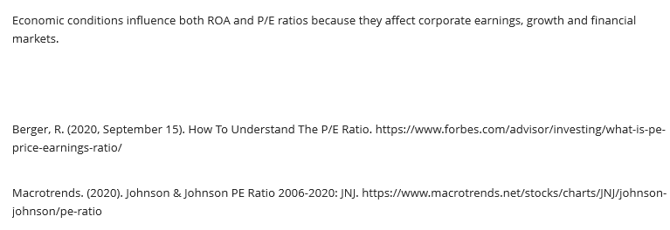

Hello Gritters,
When you divide the net income by the average assets of a company, the percentage found is the Return on Assets. As you have stated, one can easily judge how effective a company’s management is in using its assets to generate income by using ROA. For instance, Johnson & Johnson has a return of 9.6 percent for every dollar of asset it invests. ROAs above 5 percent are considered to be good which means that Johnson & Johnson must have generated high income from its investments in the mentioned financial year. Price to earnings ratio can also be termed as earnings multiple or price multiple. As you stated, the PE ratio of the company was 23.41, which means investors are willing to pay 23 dollars for every dollar of company earnings. PE ratio helps a company guess what it expects to bring in, in the future. Basically, both PE ratio and ROA are of relevance to the company, with respect to how it makes its investments.

